Applying to Fight for Sight via BenefactorCloud

Step 1: Accessing the System
- New users: If this is your first time applying to Fight for Sight via BenefactorCloud, click Register in the top right corner.
  - Enter the requested details which include your name, email and organisation.
  - After registering, you’ll receive a confirmation email. Click the link in the email to activate your account and log in.
- Returning users: If you’ve applied before, click Login in the top right corner.


Step 2: Updating Your Details
- Once logged in, ensure your profile details have been completed and are up to date.
- Click Apply as an Organisation and fill in the required information.
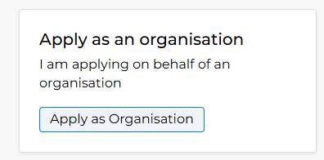
- A message saying "Your details have been updated" should appear above the Applicant Type section.

Step 3: Start Your Application
- Click Apply at the top of the screen.

- Click Start an application at the bottom right of the Digital Inclusion 2025/26 funding round.
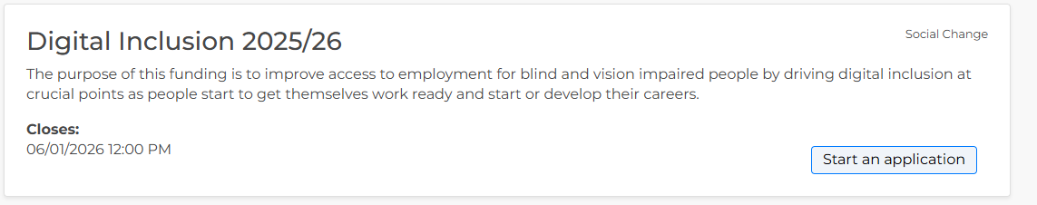

Step 5: Check Eligibility
- Choose your organisation type from the dropdown menu.
- If eligible, you’ll be able to proceed with the application.

Step 6: Completing the Application Form
- Your progress is saved automatically when you navigate between sections.
- Screen reader users: We recommend using arrow keys instead of the Tab key to navigate the form.
- If you want to download a copy of your application after you have completed it:

  - Click Expanded View above the Completing Your application section.
2. Click Print Form
3. In the print dialog, set the Destination to Save as PDF.
- After submitting your application, you should receive a confirmation email if you do not receive an email within one working day please contact grantsadmin@fightforsight.org.uk

Need Help?
- If you have any questions or run into any issues, please contact us at grantsadmin@fightforsight.org.uk or call 020 7620 2066 and ask for the Impact Team.
- Once you have submitted you’re application, you will be able to message the team directly through the portal.

