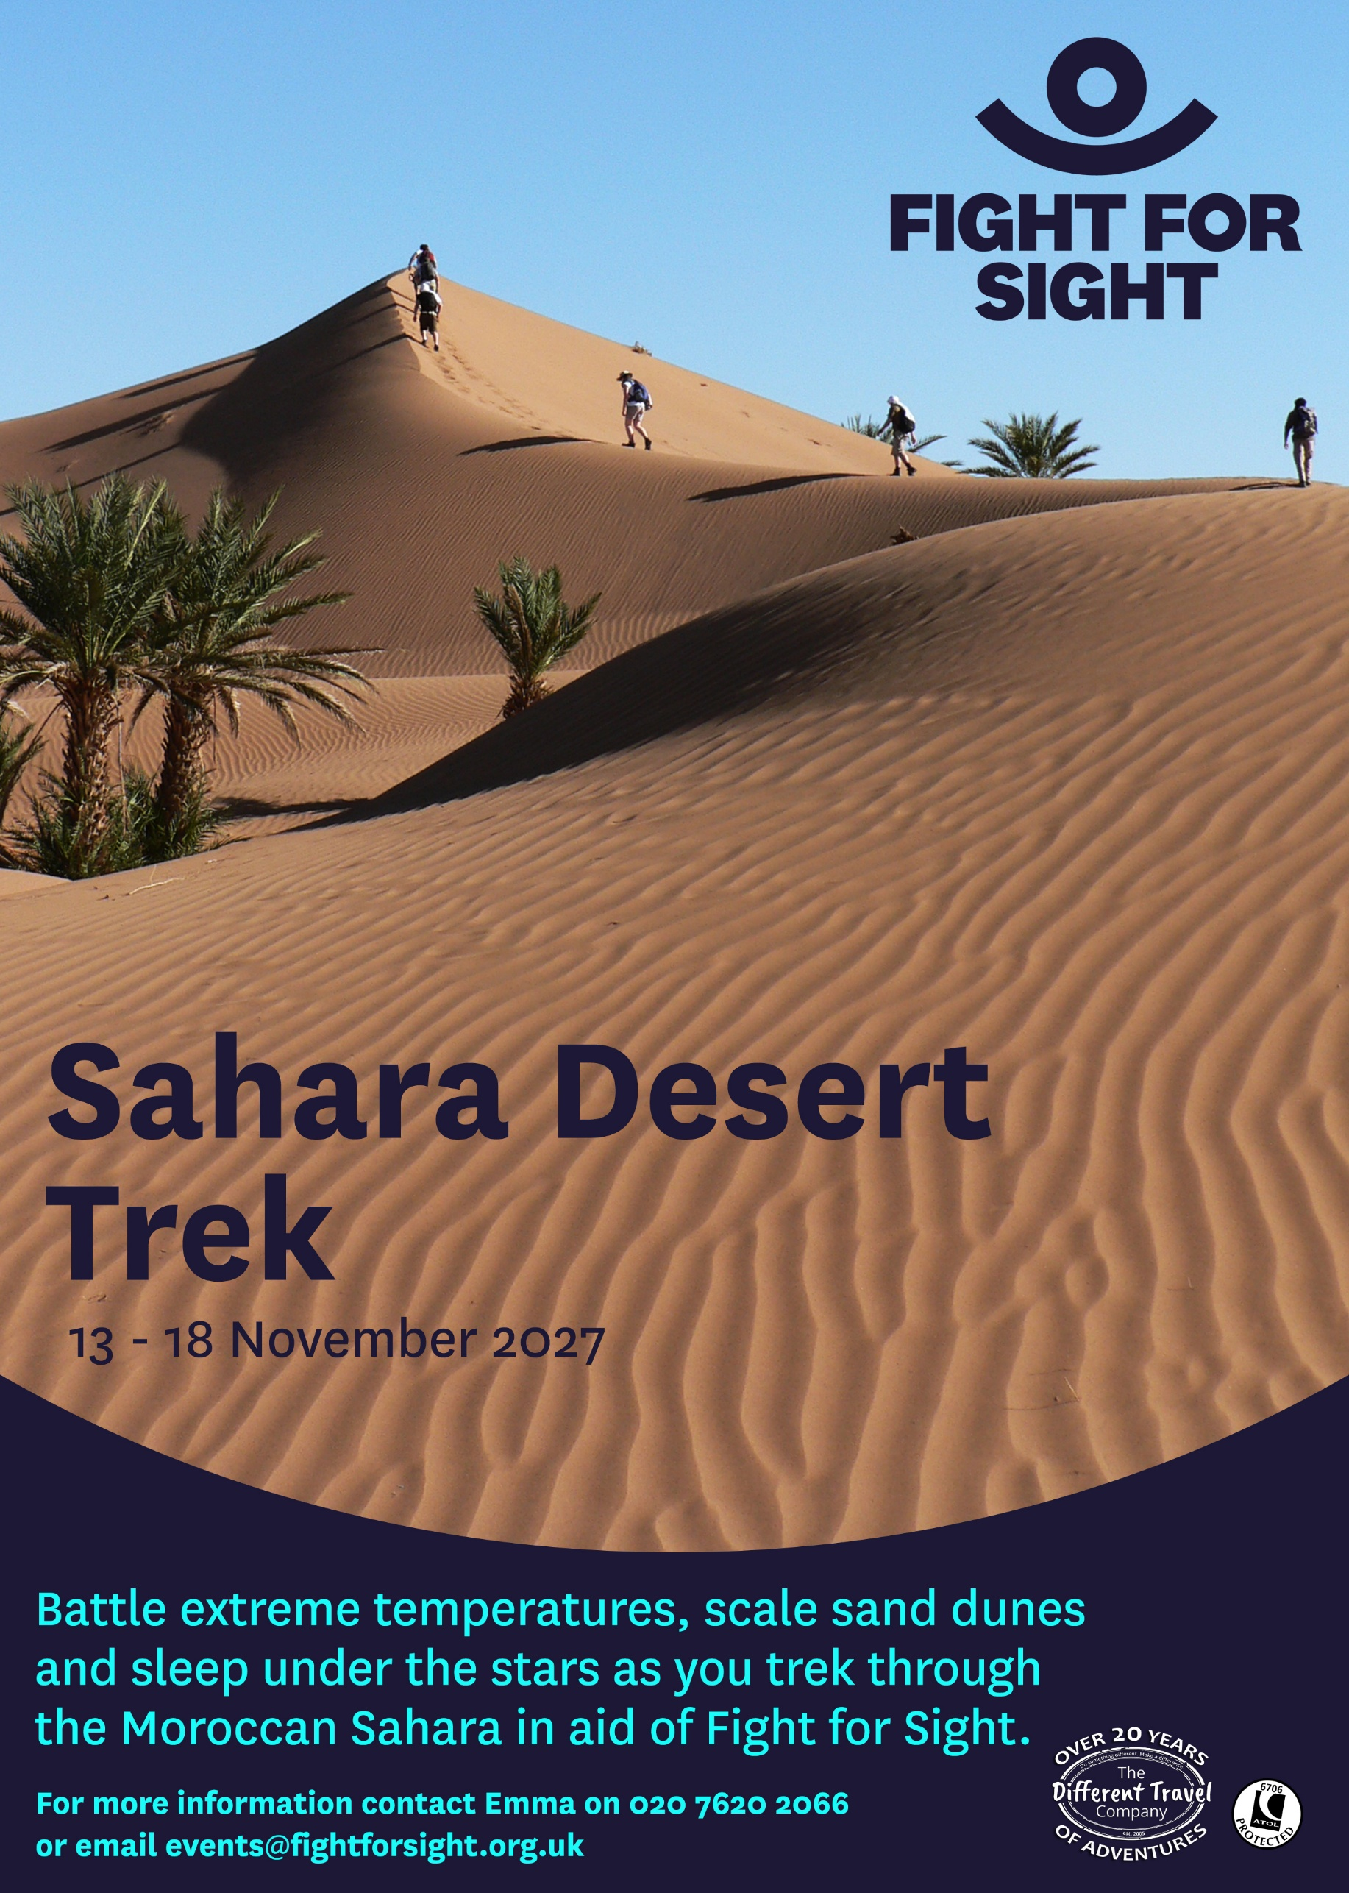
Trip Dossier and Kit List

Sahara Desert Trek for Fight for Sight 13 – 18 November 2027
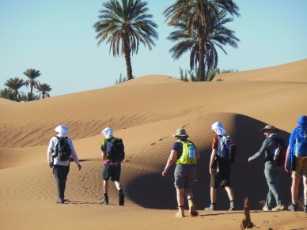
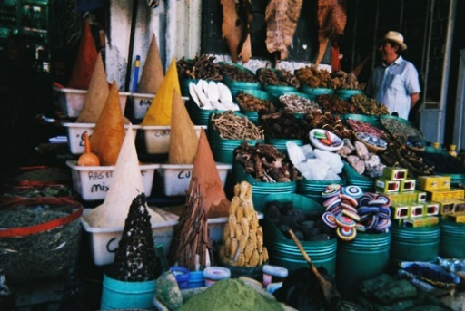
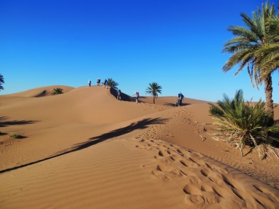
Trip overview
The Trek
This trek in the Moroccan Sahara gives you an insight into this vast and diverse landscape as well as the Berber way of life. You will spend two full days and two shorter days trekking across ancient dried-up river beds, sand dunes and vast sun-baked plains. Camping each night gives you a chance to experience the stunning stars in the night sky (weather permitting), and the traditional Berber cuisine cooked by the team is second to none.

Morocco
Situated in Northwest Africa, the Kingdom of Morocco has a population of over 38 million people. Morocco has a diverse geography with Atlantic and Mediterranean coastlines and a rugged mountainous and desert interior. The mighty Atlas Mountains and vast Sahara Desert make Morocco an adventure lover's paradise, and Marrakech is a wonderful place to visit with its spicy aromas, peaceful mosques, diverse entertainers and a cacophony of merchants in the bustling medina.

Sahara
The Sahara covers an area of over 3,600,000 square miles, making it the third largest desert on the planet (after Antarctica and the Arctic, respectively). It stretches from the Mediterranean and Atlantic to the north, the Red Sea to the east, and as far south as the Niger River. The Sahara is the world’s hottest desert with record temperatures exceeding 50°C. Despite its inhospitable conditions, the Sahara has many species of flora such as acacia, palms and grass, which have adapted to the arid conditions.

Berbers
The Berbers (or Amazigh – ‘free people’) are an ethnic group indigenous to North Africa whose culture can be traced back over 4,000 years. Traditionally, Berber men take care of livestock, and Berber women take care of the home and make handicrafts for use around the home and to sell. The lifestyle is generally nomadic or semi-nomadic, and there are large Berber communities in the rural parts of the country.
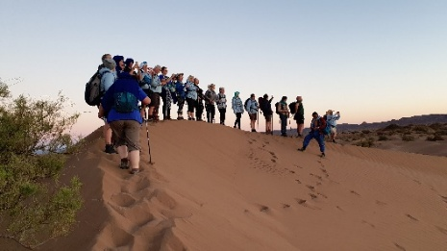
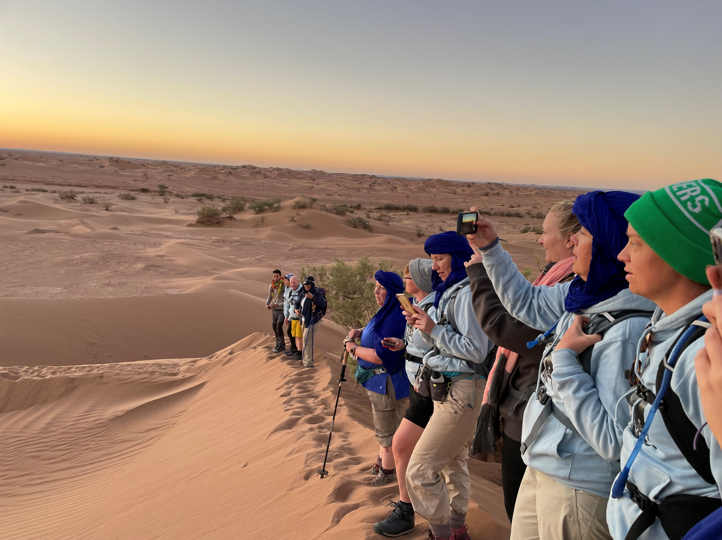
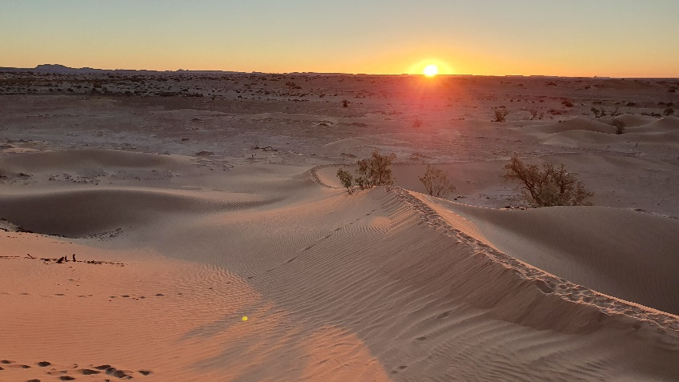
What is the experience like?

Who accompanies us?
You will be accompanied by professional English-speaking Berber guides who have an excellent knowledge of culture and hiking in the region. The guides are first-aid trained and will support you throughout your journey. You will also be accompanied by a team of support staff including cooks and camel handlers, and a Different Travel Company UK tour manager.

How tough is it?
The trek is rated moderately challenging for someone of a good fitness level. The terrain is a mixture of hard, flat, sundried plains, dried-up ancient riverbeds, wide, sandy dune fields and hard rocky outcrops. Temperatures pose a specific challenge and can reach 35°C. You must be of a good fitness level before departure, to ensure fast recovery each day.

What is the climate like?
Temperatures typically range from 25°C to 35°C during the day and drop to around 0°C at night. However, you must be prepared for variations to this. Weather during the trek will be dry but there may be some strong winds. Rain, although very rare, is not impossible. Please note: the temperatures and conditions above are historically accurate but climate change can impact the seasons so you may experience uncharacteristic conditions during the trip that are beyond our control. The guides will assess the situation and make decisions to ensure the safety and enjoyment of the group.

How do we get to the desert?
To get to and from the desert requires long drives (approx. nine hours including breaks) along winding mountain roads that offer stunning views of the snow-capped peaks and lush valleys. If you suffer from motion sickness, you are advised to bring your usual anti-nausea medication with you. Regular stops are taken.

What is the camping like?
During the trek, you will sleep in tents (two to a tent), or if the weather is good, you can sleep outside under the stars - highly recommended! Foam sleeping mats are provided, but you will need to bring a sleeping bag. Additional lighting has been provided at camp.Toilet facilities are likely to consist of a small privacy ‘tent’ over a basic compostable toilet with a seat. There are no showers or bathing facilities in the desert, so you should bring a pack of baby wipes.
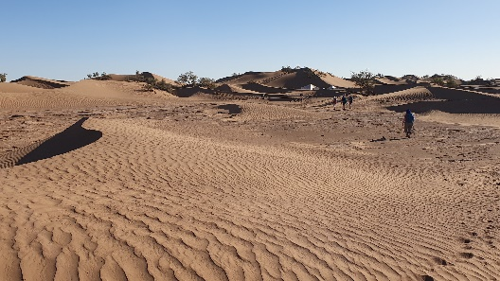
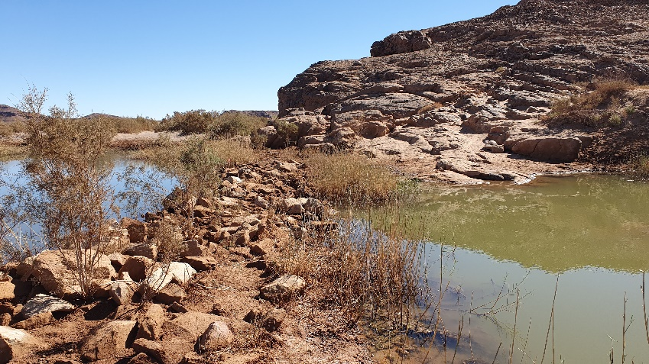
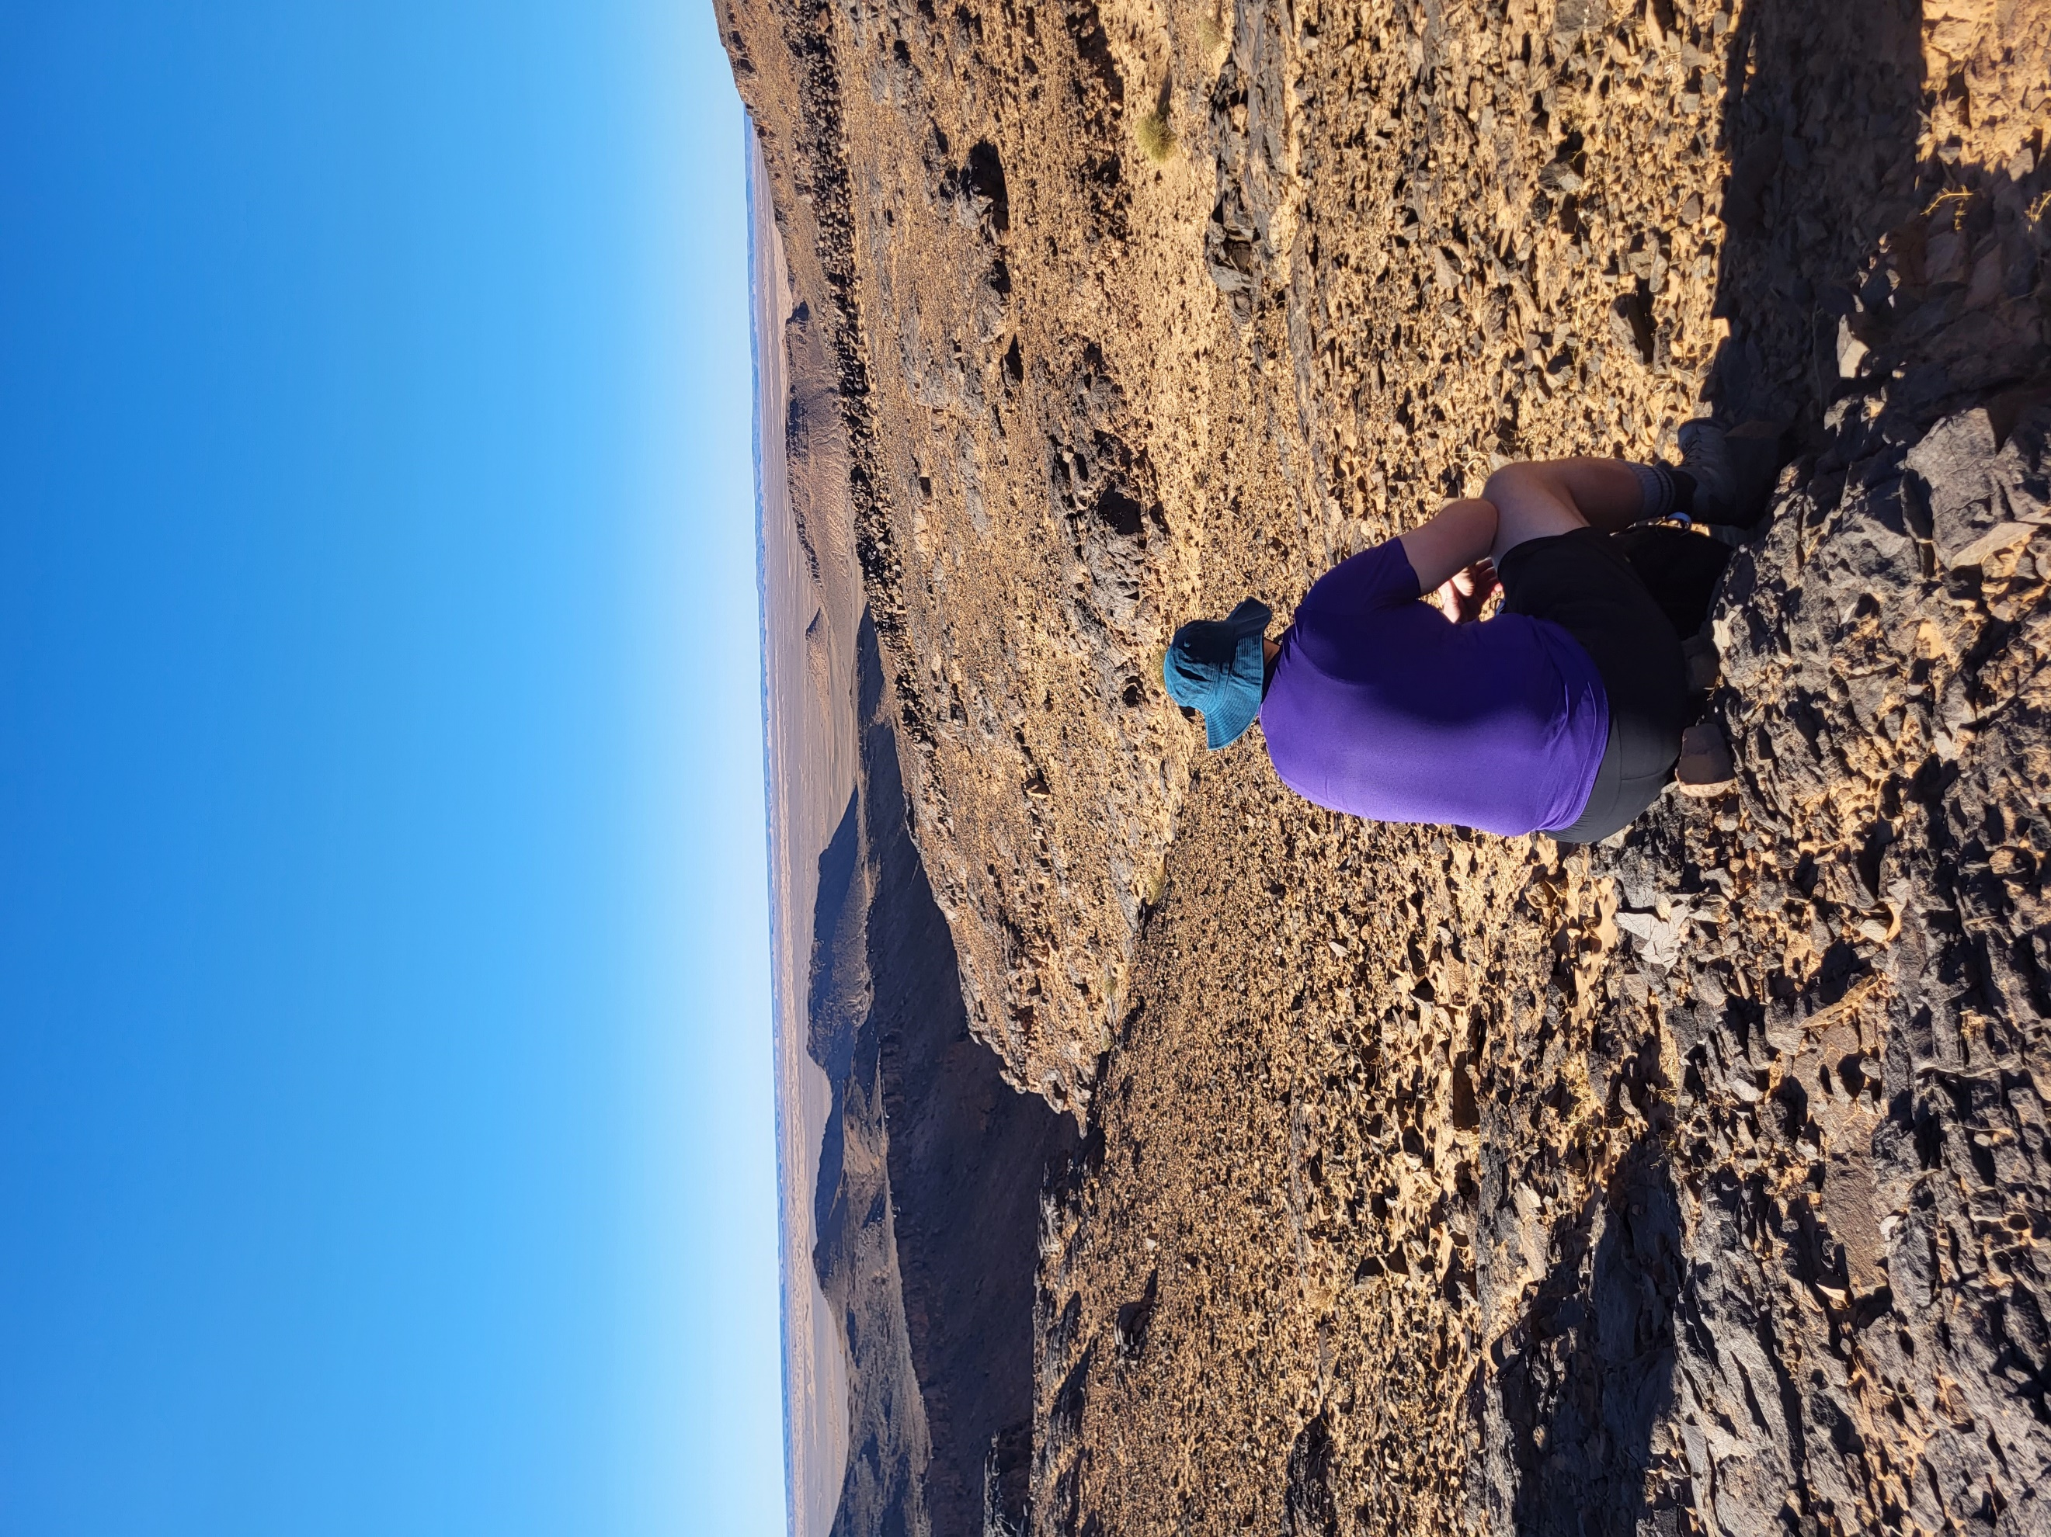
What is the food like?
During the trek, meals are cooked by a chef who will prepare Moroccan dishes. Breakfast and lunch will be eaten ‘alfresco’, and evening meals will be in a mess tent at camp. Plates, mugs, cutlery and other equipment are provided. While staying in Marrakech (and Ouarzazate if applicable), meals will be at the hotel or at local restaurants.

Practical information

Who can take part?
The minimum age is 18. It may be possible to participate if you are 16 or 17 years old but you must be accompanied by a parent or guardian. There is no upper age limit. The ideal candidate would be fit, healthy and determined, open to adventure and adaptable to unexpected changes.

You may join this challenge if you are visually impaired; however, if you usually use a guide dog or require assistance, you may wish to bring a guide to help you. Your guide will be required to pay full price and book as a participant

Medical Declaration
We require a medical form to be completed by everyone upon registering, and any pre-existing conditions, medications used and other medical issues must be specified. All your data, including medical details, is treated in the strictest confidence.

The information will be securely screened by a qualified medical professional, and details provided to your tour manager and local guides so our staff are adequately informed and prepared to support you during the trip. It is a condition of your registration that you give full and accurate details. If any details change, you must update us. By completing the booking form, you are giving consent for us to contact you confidentially with any follow-up questions regarding your health.

If your medical issues at the time of booking represent a concern for your safety and wellbeing, or the safety and wellbeing of others in the group, it may be recommended that you do not take part. If this happens, your deposit will be refunded.
If you develop a new medical condition after making a booking and this results in your withdrawal from the event, this will be treated as a cancellation by you. Please refer to the terms and conditions at the time of booking. Please note that we will never unreasonably deny participation on a trip nor contravene the Equality Act 2010.

Health & Safety Assurance

Your health and safety are our highest priorities, and we are committed to ensuring your trip is not only memorable but also safe.

We closely monitor guidance from the British Foreign, Commonwealth and Development Office (FCDO), which provides up-to-date travel advice and recommendations. All adventure travel involves an element of risk. We will never operate a trip in an area against the advice of the FCDO, whether due to health concerns, political instability, natural disasters, or any other safety threat.

If travel restrictions in the destination country prevent the trip from going ahead safely, we will offer the option to postpone or cancel your booking at no cost to you.

We will keep you fully informed of any updates relevant to your travel arrangements.

If you have any questions or concerns, feel free to reach out to us at info@different-travel.com.

ATOL Protection

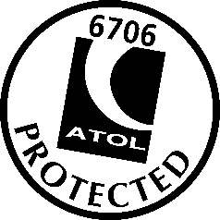
This trip is operated by The Different Travel Company (ATOL 6706) for Fight for Sight (Registered Charity No 1111438).

The flight-inclusive trip in this brochure is financially protected by the ATOL scheme.
When you pay you will be supplied with an ATOL Certificate. Please ask for it and check to ensure that everything you booked (flights, hotels and other services) is listed on it. Please see our booking conditions for further information or for more information about financial protection and the ATOL Certificate go to: www.caa.co.uk.

Trip cost

A non-refundable registration fee of £395 is payable on booking to confirm your place. You should then fundraise a minimum of £2,400 for Fight for Sight.

A minimum of £1,920 (80%) must be fundraised by 21 August 2027. The remainder must be paid by the date of departure.

What is included? | What is excluded?
- Return flights from UK (inc. current taxes and fuel surcharges)  - Transfers and transport in Morocco  - Accommodation in hotels (2 nights)  - Tents and sleeping mats on trek (3 nights)  - All meals as specified  - Local guides, camels and camel handlers on trek  - Extra lighting at campsite  - Compostable toilets  - Different Travel UK tour manager  - Fundraising support | - Travel insurance  - Transport to/from UK airport  - Tips (£40pp)  - Personal expenses (e.g. drinks, souvenirs etc.)  - Vaccinations
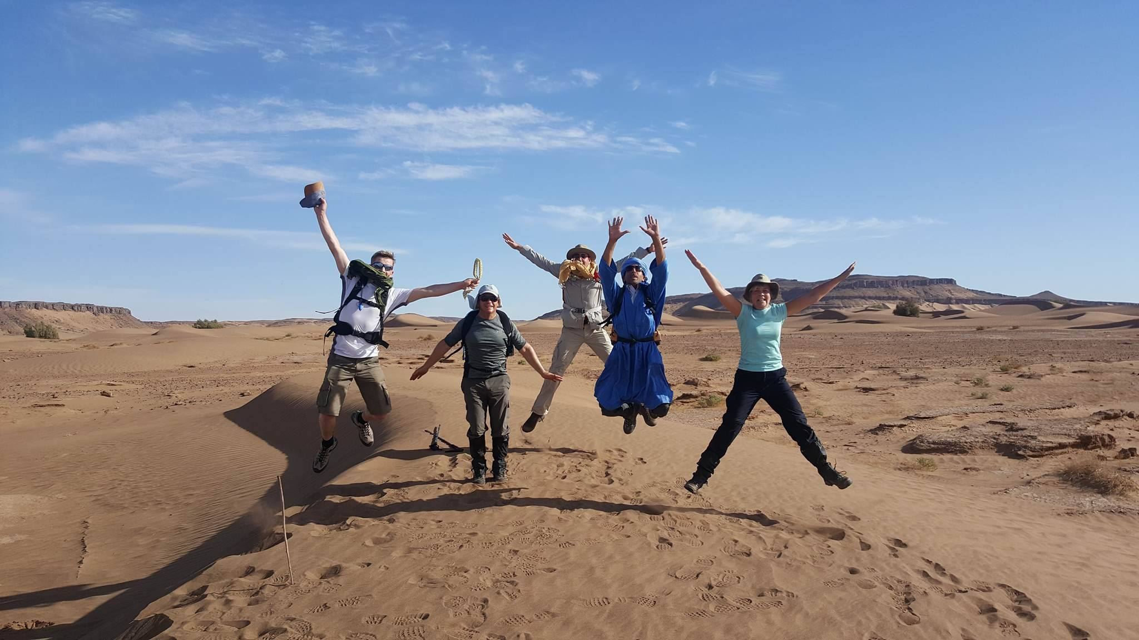
Itinerary

Day 1 (Saturday 13 November 2027): UK to Marrakech
We will fly together to Marrakech, where we are met by our guide and transferred to our hotel for the night. Depending on flight arrival times, we may start the journey to the desert today and stay in Ouarzazate tonight (approx. 4-5 hours).
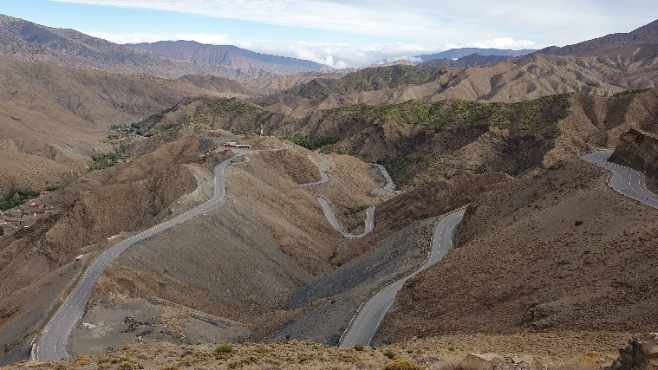
Meals: Dinner

Day 2 (Sunday 14 November 2027):
Marrakech to Sahara
If staying in Marrakech, we set off early, crossing the Atlas Mountains and following ancient caravan routes into the Sahara, stopping for lunch in Ouarzazate on the way (journey time approx. 9 hours including stops.) If starting in Ouarzazate, the journey to the desert takes approximately 4-5 hours. This afternoon we will arrive in the desert and be welcomed by the rest of the trek team and the camels before commencing our trek, stopping overnight to camp under the stars.
Approx. trek distance: 5km. Meals: Breakfast, lunch, dinner
Days 3–4 (Monday 15 – Tuesday 16 November 2027): Sahara Desert
Our trek continues through the desert as we traverse sand dunes and rocky, lunar landscapes for the next two days. We are aided by our local Berber team comprising guides, cooks and camel owners (the camels are our porters, carrying our luggage and equipment). Each day you will enjoy the varied Saharan landscape and learn how important it is to respect and comply with the forces of nature in the desert. On average we will cover 15-20km per day, but this will vary. As the trek progresses, we learn how the nomadic people of the Sahara live: from cooking to sleeping out under the stars and reading the magnificent Saharan night sky.
Meals: Breakfast, lunch, dinner

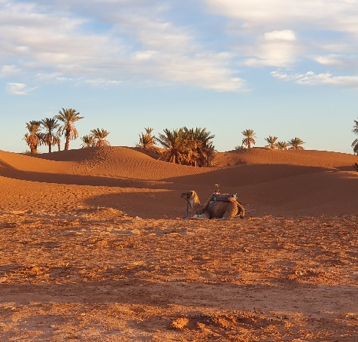
Day 5 (Wednesday 17 November 2027): Sahara to Marrakech
This morning it’s the final leg of the trek to a small village where we bid farewell to the trek team and head back to Marrakech (approx. 9 hours’ drive).
Approx. trek distance: 5km.
Meals: Breakfast, lunch, dinner

Day 6 (Thursday 18 November 2027):
Marrakech to UK
Depending on flight times, you may have some free time to explore Marrakech before your flight back to the UK.
Meals: Breakfast

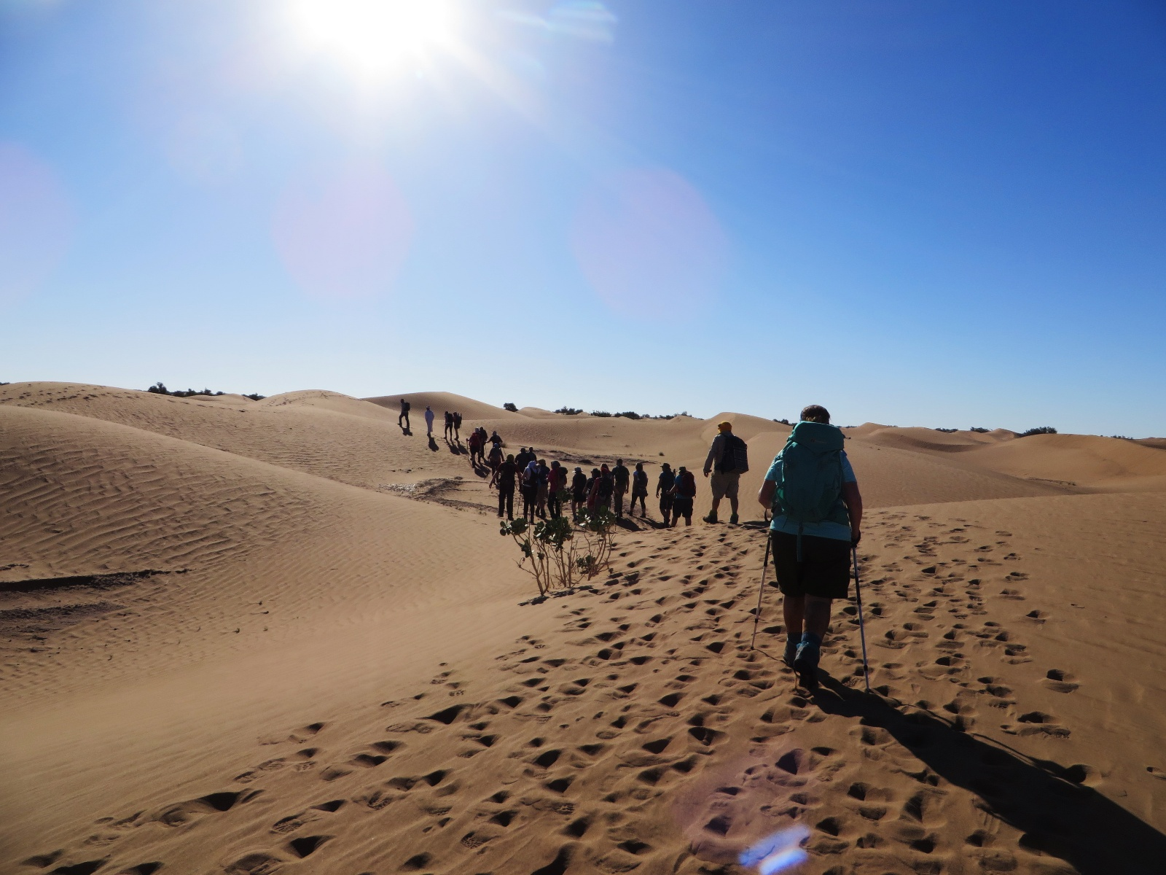
N.B. This itinerary may change due to weather, the ability of the group and so on. We will do our best to keep to the itinerary, but we cannot be held responsible for changes beyond our control. In all circumstances your guide and tour leader will have the final say in the interest health and safety.

